EE3008A/B – Linear Systems and Signal Processing
Department of Electrical Engineering
The Hong Kong Polytechnic University

MATLAB Exercise for Hw 2
(Due date: Thurs. Oct 19, 2025)

In this exercise, we will use MATLAB to develop different filters, including the low-pass filter and the high-pass filter, and see how these filters change your music.
- Load the music waveform into MATLAB
- Extract a 10s clip from the original music
- Apply Fourier Transform to the music clip
MATLAB has built-in function fft( ),which takes the Fourier Transform of the signal. However, there are some extra scaling and shifting operations that makes it not user friendly. Therefore, for your convenience, we provide you two files “fft_PolyU.m” and “ifft_PolyU.m” that define two new functions fft_PolyU( ) and ifft_PolyU( ).
[frequency,spectrum] = fft_PolyU(t,signal) for time vector called t and signal vector called signal, returns the frequency vector called frequency and discrete Fourier Transform vector called spectrum. If you have a time-domain vector with length N and sampling frequency FS, then the fft( ) will give you a length N vector in frequency –½ FS to ½ FS in steps of FS/N. The function also plots the double-sided amplitude plot and the phase plot of the spectrum.
[t,signal] = ifft_PolyU(frequency,spectrum) for frequency vector called frequency and spectrum vector called spectrum, returns the time vector called t and discrete inverse Fourier Transform vector called signal.
The graph you get using fft_PolyU( ) should look like this:
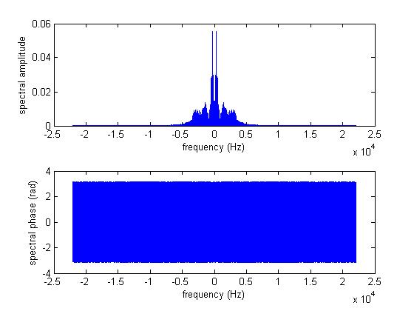
4. Set up a 1kHz low-pass ideal rectangular filter matrix
Think about a matrix H with some columns containing ‘0’s and other columns containing ‘1’s. When multiplying this matrix elementwise with the spectrum matrix, we obtain a filtered matrix. Note that the dimension of H must be the same as spectrum.
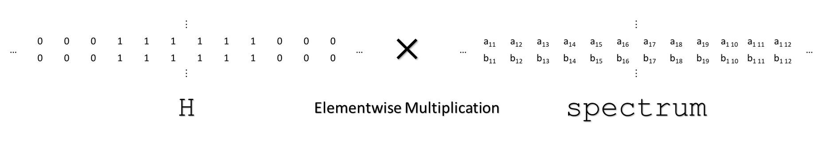
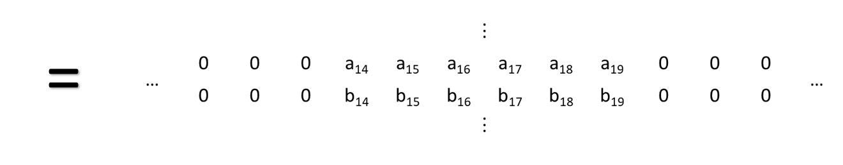
To build H, you may first set up a zero matrix and then use a for loop to change some ‘0’s into ‘1’s. As for how to transform the cut-off frequency into the indices of the filter matrix, you may want to read again the properties of fft_PolyU( ).
- Obtain the filtered matrix
Now let your original music clip go through the filter by multiplying the original matrix with the filter matrix, and be aware that “.*” means elementwise multiplication in MATLAB.
- Plot the filtered spectrum.
After going through a low-pass filter with 1KHz cut-off frequency, your plot should look something like this.
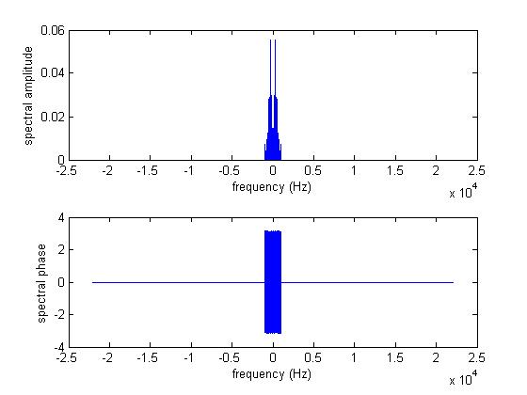
- Take the Inverse Fourier Transform using ifft_PolyU( ) to obtain the filtered time-domain data.
- Audio play your filtered vector, how does the filtered version music sound?
- Export the filtered version of your music.
- Repeat with 500Hz LPF and also 1kHz HPF
- For this exercise, you should generate two versions with low-pass filter and high-pass filter applied on respectively. Name your file “lowpass.mp4”, “highpass.mp4” when submitting.

